AE 4361 – Assignment 3

1) a)

b)

Using the provided ‘Kepler_solver’ code with t = 9*3600 = 32400s, e=0.549, M0 = 0, a=26610km

E= 4.2269 rad

$$r=a\left(1-e\cos{E}\right)=26610\left(1-0.549\cos{4.2269}\right)=33427km$$

c)

$$V=\sqrt{μ\left(\frac{2}{r}-\frac{1}{a}\right)}=\sqrt{3.986×{10}^{5}×\left(\frac{2}{33427}-\frac{1}{26610}\right)}=2.978km/s$$

d)

$$\tan{\frac{ν}{2}}=\sqrt{\frac{1+e}{1-e}}\tan{\frac{E}{2}}=\sqrt{\frac{1+0.549}{1-0.549}}\tan{\frac{4.2269}{2}}=-3.073$$

$$ν=2\arctan{-3.073}=-2.51rad$$

$$h=\sqrt{μa\left(1-e^{2}\right)}=86080.6$$

$$γ=asin\left(\frac{μ}{hv}\left(1+ecos\left(ν\right)\right)\right)=1.047rad$$

$$V_{r}=V×\cos{γ}=2.978×sin2.51=1.49km/s$$

2)

|  |  |
| --- | --- |
| Semi-major axis (a) *km* | **6877.3** |
| Eccentricity (e) | **0.1582 or [0.0379, -0.1444, -0.0524]T** |
| Inclination (i) *deg* | **20.000** |
| Right ascension of ascending node (Ω) *deg* | **30.000** |
| Argument of perigee (ω) *deg* | **255.581** |
| True Anomaly (υ) *deg* | **104.419** |

See “AE4361 HW3” starting at Q2 comment at the end of document for code.

Workspace variables for Q2:

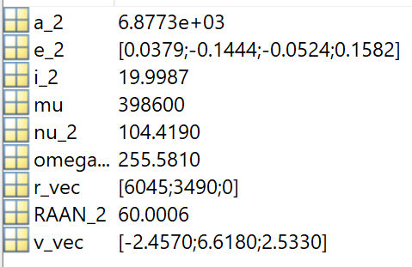

3)

a) ${\vec{r}}_{Vanguard-1}=\left[\begin{matrix}6.7758 \\ 0.3813 \\ 2.0544\end{matrix}\right]×{10}^{6}$ m

b) ${\vec{r}}_{Hubble}=\left[\begin{matrix}-5.5368 \\ -3.8525 \\ -1.4916\end{matrix}\right]×{10}^{6}$ m

c) ${\vec{r}}_{Molniya comms sat}=\left[\begin{matrix}0.6497 \\ 1.3425 \\ 3.0208\end{matrix}\right]×{10}^{7}$ m

d) ${\vec{r}}_{Starlink 3327}=\left[\begin{matrix}-3.7498 \\ 2.3053 \\ 5.0795\end{matrix}\right]×{10}^{6}$ m

See code and function on next pages.